# Kanban – Customer LSA

The prebuilt *Kanban – Customer LSA* provides an overview of last sales activity (LSA) with registered customers in your NetSuite account. Each Kanban column represents a time period for when last sales activity occurred.  
  
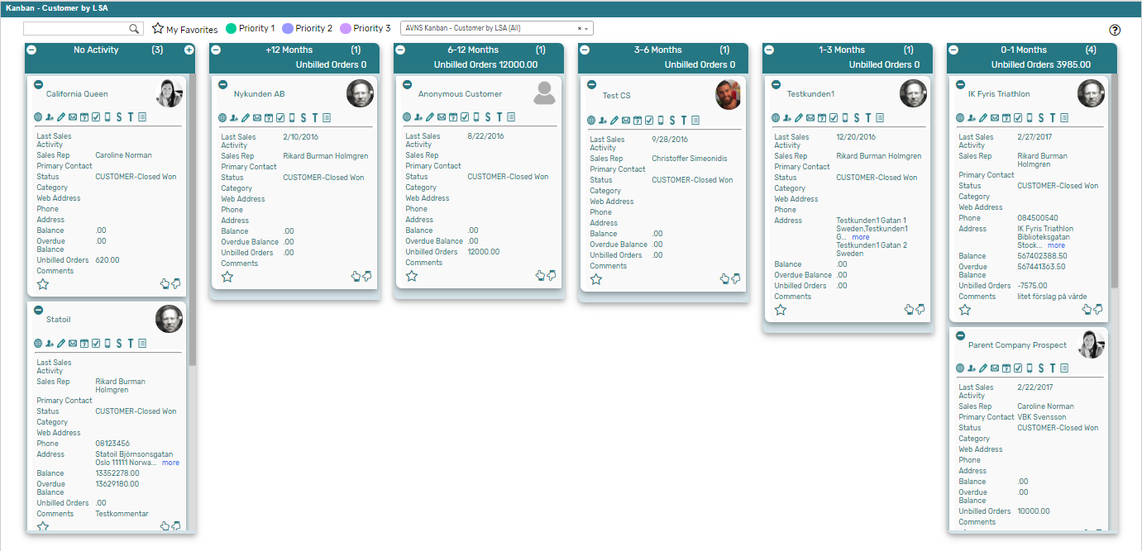

### Kanban – Customer by LSA: Prerequisites

Before using the *Kanban – Customer by LSA* board, please make sure the prerequisites listed below are fulfilled in order for the board to function as expected.

1. 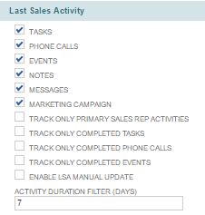**Last Sales Activity**  
   Since the columns of the prebuilt *Kanban – Customer by LSA* board are based on Last Sales Activity (LSA), it is important that this feature is enabled in your NetSuite account. For all new NetSuite account the LSA functionality is enabled by default, in older NetSuite accounts the functionality can by enabled by installing the Last Sales Activity bundle from NetSuite (bundle 53195).  
     
   Which activities to include to Last Sales Activity is defined per NetSuite account. Navigate to Setup 🡪 Company 🡪 General Preferences and the subtab *Custom Preferences* (Administrator) to define the preferences for the NetSuite account.
2. 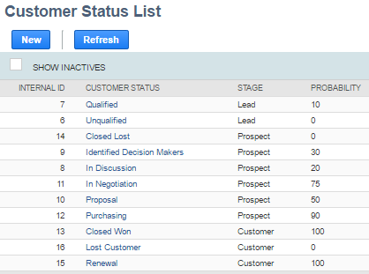**Customer Status**  
   When adding a card to the first column of the prebuilt *Kanban – Customer by LSA* board, the customer status of the record will be set to a NetSuite standard Customer status. Therefore, it is important that the statuses referred to in the board are available in your NetSuite account.   
     
   Navigate to Setup 🡪 Sales 🡪 Customer Statuses (Administrator) to find the list of Customer Statuses available in your NetSuite account. Compare the list from your NetSuite account with the Customer Status list which the prebuilt *Kanban – Customer by LSA* board is based on (picture below).   
     
   If the Customer Statuses differ between your NetSuite account and the picture above, you will need to edit the settings of the Kanban Columns for the *Kanban – Customer by LSA* board.  
   ***Please refer to the section ‘Kanban Columns’ in the ‘Kanban User Guide’***
3. **Sales Rep & Sales Rep Image**  
   Make sure to mark the checkbox ‘Sales Rep’ on the Employee record for all available Sales Reps.   
   If an image has been uploaded to the *Image* field on the Employee record, this image will be displayed on the Kanban card. If no image is available, a predefined profile icon will be displayed instead.
4. **Report 360**The *Kanban – Lead-Prospect-Customer* board includes the *Customer 360* PDF-report, built with native SuiteApp Report 360. To enable the *Customer 360* report, the SuiteApp Report 360 (bundle 106006) and Report 360 Prebuilt reports (bundle 120140) are required. Make sure to install both bundles in order to display the *Customer 360* report.

Kanban – Customer by LSA: Card Moves & Column Actions

The *Kanban – Customer by LSA* board contains six Kanban Columns, based on Last Sales Activity. This Kanban function differently from other Kanban boards, as the cards can only be moved via Card Actions and not through drag and drop. Only the first column is configured with a Column Actions. Double clicking on any card in the *Kanban – Customers by LSA* board will open the customer record in edit mode.

1. **No Activity***Customer records with no activities registered as Last Sales Activity.*
   1. *Card Moves* – None, only via Kanban Card Actions.
   2. *Column Actions* – when adding a Kanban card to the column the status of the record represented in the Kanban card will be updated to *CUSTOMER* – *Closed Won*.
   3. *Add Card* – it is possible to add a Kanban card (a new record) from the column *No Activity* by clicking on the + icon in the top right corner of the column.
2. **+12 Months***Customer records with activities registered as Last Sales Activity over 12 months ago.*
   1. *Card Moves* – None, only via Kanban Card Actions.
   2. *Column Aggregation* *–* the column aggregation in the *+12 Months* column calculates the sum of all unbilled orders for the records in the column, to display the amount in the column header section.
3. **6-12 Months**

*Customer records with activities registered as Last Sales Activity between 6-12 months ago.*

* 1. *Card Moves* – None, only via Kanban Card Actions.
  2. *Column Aggregation* *–* the column aggregation in the *6-12 Months* column calculates the sum of all unbilled orders for the records in the column, to display the amount in the column header section.

1. **3-6 Months**

*Customer records with activities registered as Last Sales Activity between 3-6 months ago.*

* 1. *Card Moves* – None, only via Kanban Card Actions.
  2. *Column Aggregation* *–* the column aggregation in the *3-6 Months* column calculates the sum of all unbilled orders for the records in the column, to display the amount in the column header section.

1. **1-3 Months**

*Customer records with activities registered as Last Sales Activity between 1-3 months ago.*

* 1. *Card Moves* – None, only via Kanban Card Actions.
  2. *Column Aggregation* *–* the column aggregation in the *1-3 Months* column calculates the sum of all unbilled orders for the records in the column, to display the amount in the column header section.

1. **0-1 Months**

*Customer records with activities registered as Last Sales Activity within the last month.*

* 1. *Card Moves* – None, only via Kanban Card Actions.
  2. *Column Aggregation* *–* the column aggregation in the *0-1 Months* column calculates the sum of all unbilled orders for the records in the column, to display the amount in the column header section.   
       
     

### Kanban – Customer by LSA: Available Card Actions

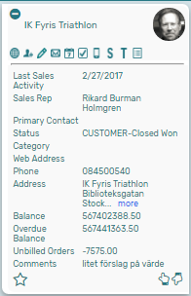The Kanban cards in the *Kanban – Customer by LSA* board each contains ten Card Actions. Card actions regarding activities will update the Last Sales Activity field, making the card move to the appropriate column in the *Kanban – Customer by LSA* board.

1. **Customer: View Customer 360**  
   View a Customer 360 report of the customer from the Kanban card.
2. **Customer: New Contact**Add a new contact to the customer from the Kanban card.
3. **Customer: New Note**Add a new note to the customer from the Kanban card.
4. **Customer: New Email**Add a new email to the customer from the Kanban card.
5. **Customer: New Event**Add a new event to the customer from the Kanban card.
6. **Customer: New Task**Add a new task to the customer from the Kanban card.
7. **Customer: New Phone Call**Add a new phone call to the customer from the Kanban card.
8. **Customer: New Sales Order**Add a new sales order to the customer from the Kanban card.
9. **Customer: Show Transactions**Show a list of all transactions related to the customer from the Kanban card.
10. **Customer: Show Activity**Show a list of all activities related to the customer from the Kanban card.

### Kanban – Customer by LSA: Alternative Searches

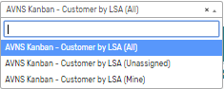There are three alternative searches for the *Kanban – Customer by LSA* board.

1. **AVNS Kanban Customer by LSA (All)**This search will display all registered customers in the *Kanban – Customer by LSA* board.
2. **AVNS Kanban Customer by LSA (Mine)**This search will display registered customers where Sales Rep is *Mine* (current user) in the *Kanban – Customer by LSA* board.
3. **AVNS Kanban Customer by LSA (Unassigned)**This search will display registered customers without an assigned Sales Rep in the *Kanban – Customer by LSA* board.

### Kanban – Customer by LSA: Available Colors

There are three colors available for the *Kanban – Customer by LSA* board, which can be used to highlight and filter the Kanban cards (*Priority 1 // Priority 2 // Priority 3*). These are defined in the *Color* subtab of the Kanban configuration record.